Subject: Welcome to a New Level of Secure Browsing with ConcealBrowse

Dear Team,

You might have noticed a new extension when you go to your browser recently. We are excited to announce the deployment of ConcealBrowse, a state-of-the-art browser extension designed to enhance our online privacy and security. This initiative is part of our ongoing commitment to safeguarding our digital workspace while ensuring seamless access to the resources you need.

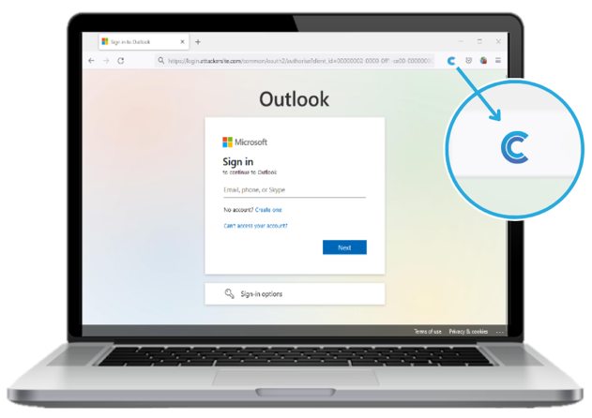

What is ConcealBrowse?
ConcealBrowse is an innovative tool that integrates directly with your browser to create a secure browsing experience. In an instance where a site looks suspicious, Conceal will isolate the activity to thwart any malicious activity. The tool will also block any known malicious sites or sites that are out of policy. Its primary purpose is to protect our company’s sensitive information from potential online threats and to ensure that our internet browsing remains confidential and secure.

What to Expect
Upon initiating a browsing session that requires enhanced security, you will be greeted by a splash screen indicating that you are entering a protected, isolated environment. This feature is a visual confirmation that ConcealBrowse is actively securing your session, providing you with peace of mind as you access the internet.

Key Features and Benefits:

Enhanced Privacy: ConcealBrowse ensures that your online activities are shielded from prying eyes, protecting personal and company data from potential breaches.
Secure Browsing: By creating an isolated environment, the extension prevents malicious software and phishing attempts from compromising our systems.
User-Friendly Interface: Despite its robust security measures, ConcealBrowse is designed to be intuitive and easy to use, requiring minimal adjustment from your usual browsing habits.

Getting Started
The extension has already been installed on your browser, and no further action is required on your part to activate it. When you navigate to a site that falls under our security protocol, ConcealBrowse will automatically engage, displaying the splash screen as a signal that you are in a secure browsing mode. To learn more about getting started with ConcealBrowse as an end user, please go here.

We encourage you to continue your online activities with confidence, knowing that ConcealBrowse is working diligently in the background to protect your information. Should you have any questions or require assistance with the new extension, please do not hesitate to reach out to our IT support team.

Thank you for your attention to this important enhancement to our digital security infrastructure. Together, we can ensure a safer and more secure online environment for our entire team.

Best regards,

